NCompass Improvement and Design changes

* **Challenge 1:** We received requirement to create 2 Dedicated Backed adaptors to Ncompass with certain changes we observed that most of the Backend was handled individually in each service, which was adding extra effort by the developer to handle it in each service.
* **Solution:** We moved the backend error handling part to Common Adaptor flow, which made the work easier.

**Before the change below method need checked:**

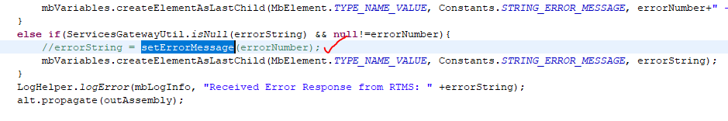

**Code snippet:**

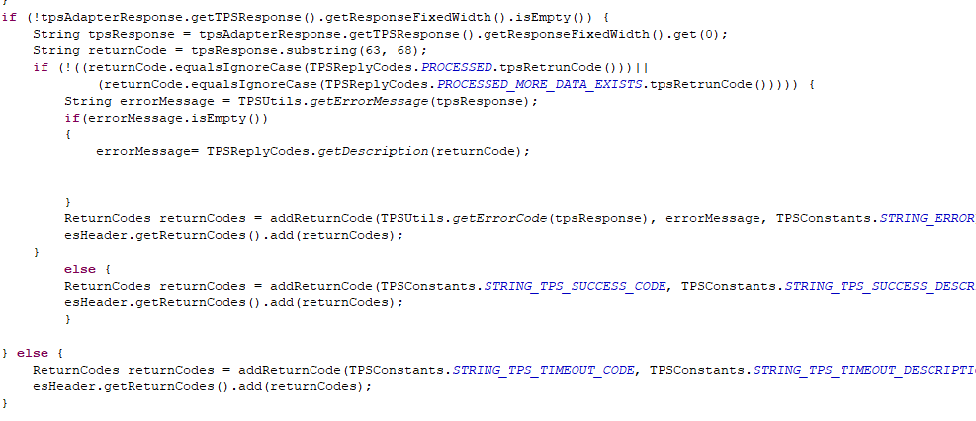

**Challenge 2:** In one of application in NCompass which interacts with Backend and DB in some scenario we were getting success from Backend and empty result set from DB, so we were updating the status as -1(Error response) but the downstream system was expecting it as success, but we can’t go against standard of 1 for success and -1 for failure.

**Solution 2:** We came up with error code 1 which means Warning on Onsite approval we made the changes in Common Library to utilize for future.

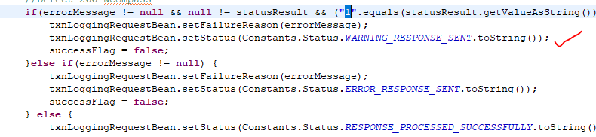

**Challenge 3:** At Initial we are asked to develop 2 Backend Adaptor with handling Basic with in code instead of DB, Since Upstream was ok send Basic Cred for adaptor irrespective the request.

**Solution 3:**  We came up with a solution to delimit the Basic auth with special character most of special character were failing at MGW finally we came up with semi colon (‘;’) to differentiate the Basic auth.

